**Instructions for Creating a User Account in 7 Easy Steps**

To create a Registry account, you must have an email address. The email address will be your user name when logging into the Registry.

There are three tutorial videos available to walk you through the registration process, which you can access when you select language on the top right of the home page. Click the links below for videos in the following languages:

**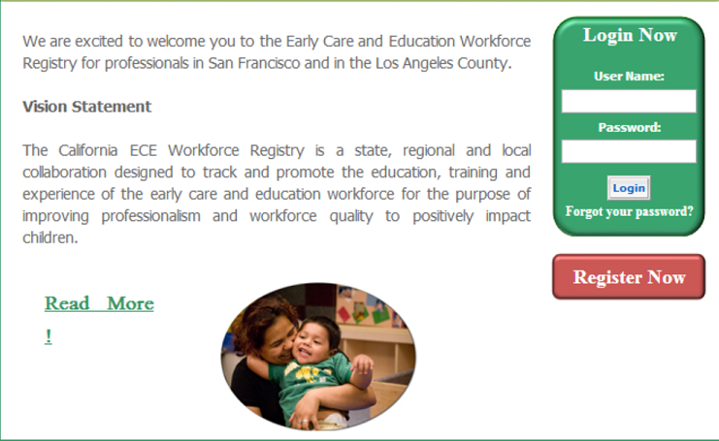**

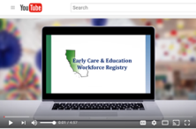**[English](https://www.youtube.com/watch?v=3J3frU3WyCY&feature=youtu.be)**

**[Spanish](https://www.youtube.com/watch?v=EEScSQkc3xI&feature=youtu.be)**

**[Chinese (Cantonese)](https://www.youtube.com/watch?v=Un2okuxjzNM&feature=youtu.be)**

The following are step-by-step instructions for creating a Registry profile. You will create and maintain only one (1) CA ECE Workforce Registry account.

1. From Home page [www.caregistry.org](http://www.caregistry.org) click **Register Now** if you do not already have an account.
2. You will enter personal information beginning with Salutation at the top of page one. Your social security number is NOT required, *unless you are participating in a stipend program.* Social security numbers are encrypted for privacy and enable stipend program administrators to issue W-9s for tax purposes. Last 5 of SSN will also enable training data collected from State funded projects to be linked to your Registry account. All other fields are required.
3. Be sure to read and **agree to**  the ***Terms of Use*** and ***Privacy Policy*** and check the box to continue to the next page.
4. Search for your employer or facility by typing in the name, address or license. Most of the facility data is entered in as listed by Community Care Licensing. *If you are a licensed Family Child Care provider or employee of an FCC, enter the last name, then first name, of the owner based on the license issued by Community Care Licensing.*
   * If you cannot locate your employer or facility after attempting various search options, select **Employer Not Listed** and enter the employer details. Registry Staff will use that information to update the facilities listed in CA ECE Workforce Registry.
5. Continue to enter details about your employment, including job title, ages of children served, wages, languages spoken with the children, etc., and then continue with Registration. (TIPS: report gross wages prior to taxes, weeks per year includes paid holidays.)
6. C:\Users\ECrane\AppData\Local\Microsoft\Windows\Temporary Internet Files\Content.IE5\52WM2J7Z\Email_Shiny_Icon.svg[1].pngNext select your highest level of education, how many college child development units you have completed, and if you hold a current Credential or Child Development Permit issued by the Commission on Teacher Credentialing or the Council for Professional Recognition.

Be sure to print your CA ECE Workforce Registry Membership Card and **use your Membership number** when you send in your education documents and sign into trainings!

1. **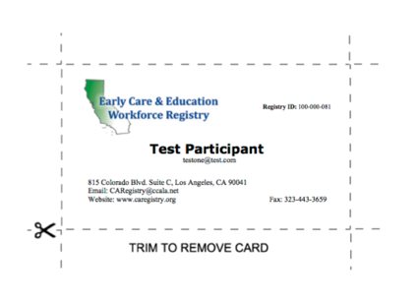**Go to your email and **login to activate your account**.

Scan or mail college transcripts, Child Development Permit and Credential document to the Registry office.