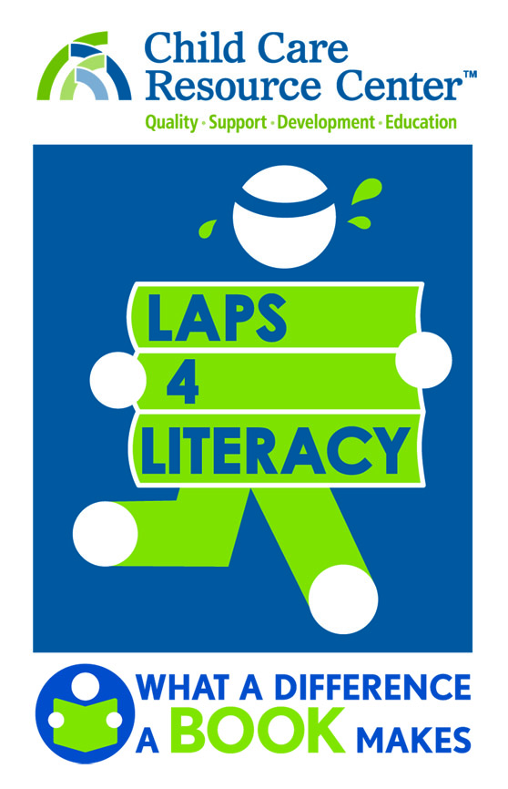
2018 BOOTH APPLICATION

APPLICANT DETAILS
Business/Organization/Group _______________________________________________________
Contact Person ___________________________
Address ____________________________________________City__________________ Zip____________
Phone ______________________________________________ |  |  |  |  |  |  |  |  |  | Fax |  | _________________________
Email ________________________________________________ |  |  |  |  |  |  |  |  |  | Website |  | ___________________________
BOOTH SPACE (10’x10’) includes one 6’ table & two chairs. Limited double-space (10’x20’) available.
DOCUMENTS The following documentation must be submitted with your application:
Vendors Proof of Liability Insurance (detailed in guidelines), CA State Franchise Resale License
Non-Profits IRS Tax Exempt Designation Letter
BOOTH SPACE 10’x10’ includes one 6’ table & two chairs. Limited double-space (10’x20’) available.
Tents & Table Covers not included.
Business or Vendor (Merchant) |  |  | $ 100.00
Non-Profit Organization: |  |  | No charge
PAYMENT
Total Due: |  |  | $
Check ______ payable to Child Care Resource Center (CCRC)
MasterCard ____ Visa _____
Name on Card _____________________________________
Card Number ______________________________________
Exp. Month/Year | ____ /____ |  |  | 3 digit CSC |  |  | __ __ __
Billing Address _______________________________________ City __________________ St _____ Zip __________
Cardholder Signature ____________________________________________ |  |  |  |  |  |  |  |  |  |  |  | Date ______________

Completed applications, payment, and accompanying documentation can be submitted via email or US Mail.

Email: ejuarez@ccrcca.org By mail: Child Care Resource Center (CCRC)
Communications Department
20001 Prairie Street
To learn more please visit www.ccrcca.org
or call us at 818-717-1036
Chatsworth, CA 91311

